Reflections
a film by Sara Broos
80/58 min/Documentary/Sweden/2016

PRODUCER

Broos Film/Sweden
Sara Broos
broosfilm@gmail.com
Tel: +46 706807767
broosfilm.com

TRAILER

www.broosfilm.com

PRESS

Rische & co

claudia@rische-pr.de

SALES

First Hand Films/Switzerland
stories@firsthandfilms.com
Tel: +41 443122060
firsthandfilms.com

FESTIVALS

The Swedish Film Institute, Sara Rüster
sara.ruster@filminstitutet.se

From Swedish reviews: “Absolutely stunning”, Mesmerazing, “A piece of art”, “Hypnotic”, “Extremely beautiful”, “One of the best Sweish Films this year”, “adorable imagery, about life, longing and sorrows”, “A mother tribute”

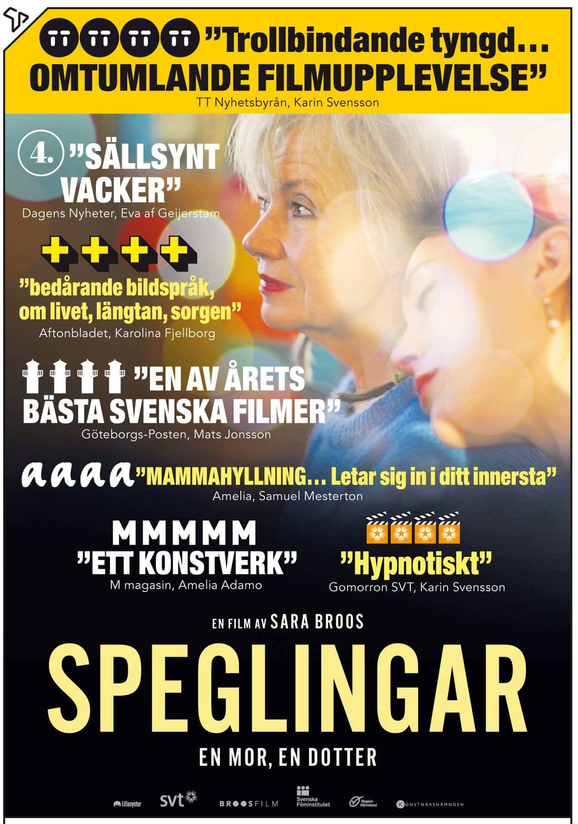

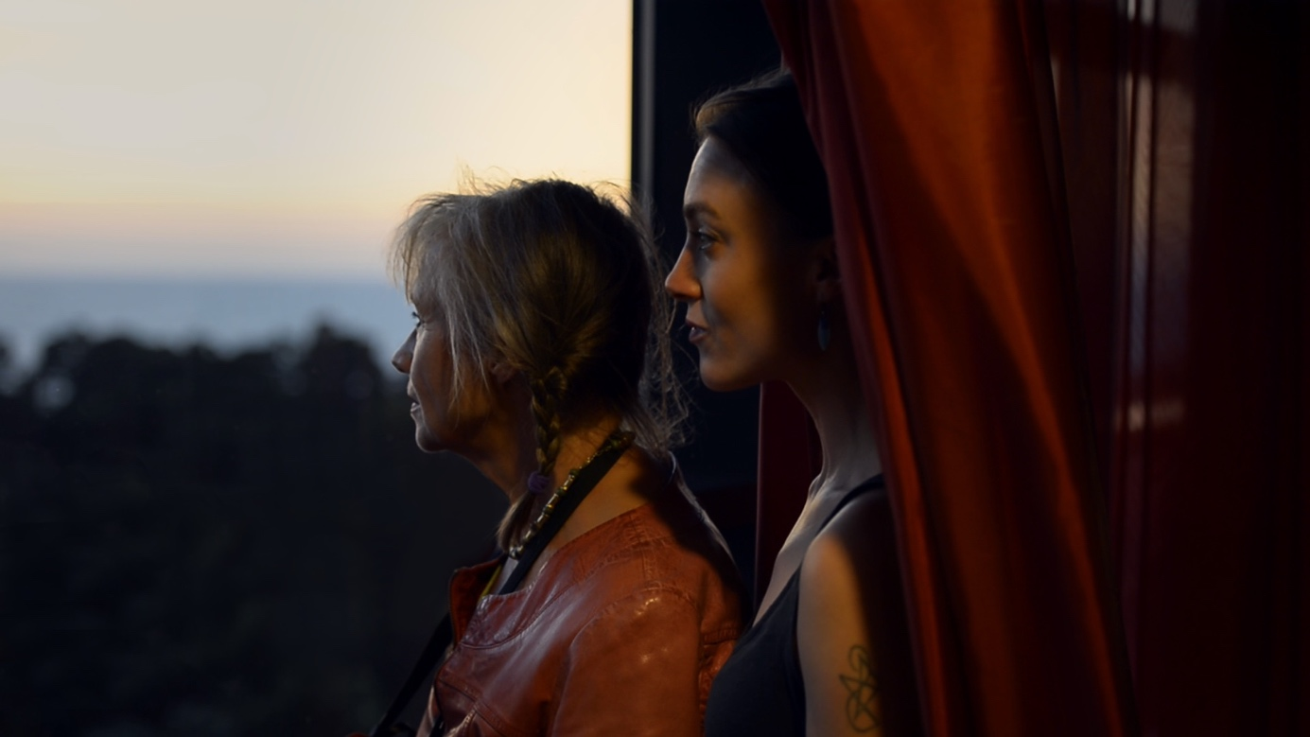

Synopsis
The director takes her mother Karin Broos, a famous Swedish painter, on a seaside trip to Latvia, hoping to close the silent gap between them. Out of this experience came an intimate and poetic film exploring the innermost recesses of the human mind and the complexities of the mother-daughter relationship. The younger and the aging woman mirroring each other's experiences – the will to live, and lack thereof – in a meditation on life and art, health and illness, secrets and shame, serenity and nightmare. A cinematic catharsis through evocations of daily life, dreams, archival material, diary notes, the mother’s paintings and captivating footage. A glimpse into the unconventional world of an artistic family in the countryside of Nordic Europe, set to a soundtrack that draws you into the story.

Director´s statement
I brought my mother to a spa resort in Latvia for her 60th birthday. It was our first trip alone together. This would be the time when we would get closer and open up to each other. Everything was arranged to that effect; the place was lovely; there was time. But a forced silence arose, and nothing was said. Instead, we escaped into our own worlds. My mother, who is an artist, was looking for motifs for new paintings. After the trip, I decided to make a film about our relationship, to try to get closer to her.

Biography Sara Broos
Reflections is written, directed, edited and produced by Sara Broos, a Swedish director and producer based in Sunne, Sweden, and Berlin. She makes author-driven, personal films and runs the production company Broos Film. She has directed and produced short films, video installations and documentaries, and received several awards as a filmmaker, including the Bo Widerberg Award 2014.

Her films have been co-produced with Swedish Television and Värmland Region with support from The Swedish Film Institute and The Swedish Arts Grants Committee. They have been released in theatres and on TV, and screened at several festivals and art museums around the world.

Filmography (selection)
2018 Notes on a Journey, documentary (in development)
2016 Reflections, documentary, 80 min. (in competition Gothenburg Film Festival, Krakow Film Festival)
2015 Homeland, documentary, 15 min. (in competition Tribeca Film Festival, Kiev Short Film Festival, Vilnius Film Festival).
2012 For You Naked, documentary, 74 min.
(Best of Fests at Idfa; In Competition, Karlovy Vary; Dragon Award Best Documentary, Gothenburg Film Festival; Best Nordic Documentary, Nordic Docs; Special Mention, Side by Side, St Petersburg; Copenhagen Mix, Doc Point)
2006 Roadside, fiction, 13 min.
2003 Time to Be, fiction, 9 min. (Best Short Film Cosmic Zoom Copenhagen)

Credits

Written, directed, edited and produced by Sara Broos
Cinematographers Billie Mintz, Hampus Linder, Sara Broos
Music Pelle Ossler
Dramaturg Stefan Jarl
Project Manager SVT Emelie Persson
Sound Design Patrik Strömdahl
Paintings Karin Broos
Graphic Design Greger Ulf Nilson
Grading Nanna Dalunde
Online Mattias Valenca
Visual Effects Peter Mettler
Animation Esteban Rivera
Graphics Pier & Pepe Francescshi
Translation Ingrid Eng
Text Editing Dimitris Saltabassis
Production Controller Jenny Örnborn
Production Assistant Olga Melnikova
Head of Communication Ylva Swedenborg
Outreach Dimitra Kouzi
Lawyer Johan Christianson
Music Producer Christian Gabel
Additional Music Sissela Broos, Kriton Klingler, Sällskapet.
Produced by Broos Film in co-production with SVT and Region Värmland

With support from The Swedish Film Institute/Cecilia Lidin &
The Swedish Arts Grants Committee
Festival Distribution Sara Rüster/Swedish Film Institute
Sales First Hand Films/Gitte Hansen

Modern Times Online:
“Letter To an Unhappy Painting”

Review by Hilde Susan Jaegtnes
Published: October 25, 2016
http://www.moderntimes.online/letter-to-an-unhappy-painting/

The daughter Sara Broos decided to make a documentary to get closer to her mum, the renowned Swedish painter, Karin Broos.

During a Latvian spa break, a mother and daughter spend time together alone for the very first time. The daughter is struck by how little they have to say to each other, how they are locked into separate worlds. Their exchanges consist mostly of the mother photographing the daughter in various poses, a common occurrence throughout the daughter’s life: She and her two sisters frequently sat for their mother and feature in many of her artistic productions. Following the silent spa break, the daughter, director Sara Broos, decided to make a documentary to get closer to her mum, the renowned Swedish painter, Karin Broos.
The film, Broos’ third feature-length documentary, comprises snippets from the director’s childhood, present-day interviews and family tableaux. It also features pictures and cuttings from the mother’s wild teenage years in Malmö in the ‘60s, a time when she experimented with drugs, suffered eating disorders and ‘sought male approval.’ Broos explains how she, as a child, would write letters to her mother’s paintings in a bid to understand why they were so unhappy. A documentary is, to a certain extent, comparable to a letter; both are created at a
specific time and reach their recipients after a time leap which brings distance, but also room for contemplation.
In her documentary For You Naked (2012), Broos follows her godfather Lars Lerin in his attempt to find love with a Brazilian he met through a personals ad. Lerin, a renowned Swedish artist most noted for his water colour paintings, is besieged by social anxiety and an alcoholic past. However, in For You Naked, the director’s sole purpose is to offer encouraging support as the godfather battles his own thoughts and struggles to connect emotionally. There are some thematic similarities between these two films and the short documentary Homeland (2015) – about a female Syrian refugee’s passionate love for music. All three feature main characters who turn their gaze inwards to comprehend and cope with their lives.
At 17, Karin Broos wrote in her diary: “I am unable to do anything. I am lying in my bed waiting. For what – I don’t know. And then I eat. The whole room is empty, and so am I. […] And then this bloody body which is impossible to get rid of. It follows me everywhere.” From age 15 to 22, Karin lived through constant hell. Her daughter Sara also suffered from anorexia and bulimia as a teenager, which the mother failed to realise due to their differing lifestyles. Where the mother was extroverted and experimental, the daughter became introverted and brooding. Both, however, experienced self-loathing, shame and a negative perception of their identities. The daughter’s view of her mother reveals great admiration, coupled with a wish for a greater degree of symbiosis than the mother is able to extend.

Reflections bears closer resemblance to a picturesque self-portrait than a traditional documentary, or rather the director’s stylised attempt to understand herself. From a young age, Broos tried to emulate her mother by wearing bright red lipstick and black eyeliner. Some of the mother’s other characteristics also manifest themselves in the daughter, such as low self-confidence and a talent for expressing herself visually.
The mother’s love is most evident as she focuses on recreating her daughters in her paintings
The style and tone of the film are heavily stylised, with colour-drenched images, striking compositions, a gliding lyrical editing, and a rich, often intrusive soundtrack consisting of slow ‘60s rock music dominated by a weeping electric guitar. The use of music, sensual close-ups and sumptuous colours create a ‘rock star’ filter effect, akin to atmospheric filmmakers such as David Lynch or Terrence Malick. One might suspect that the director has allowed the aesthetics of the mother’s colourful past and detail-rich paintings to seep into the documentary, thus increasing the sense of being present in a movable family history museum.
Värmland. Large swathes of the material were filmed in Värmland, Karin Broos’ new home when she got together with her husband. The stately home and beautiful nature would not look out of place in a Bergman-drama, a parallel also visible in thematic threads such as communication breakdown and painful, unbalanced family relationships. A scene I will remember for a long time is the meditative labour of a robotic timber cutter. With inhuman precision, one tall tree after another is cut loose, stripped of branches and divided into smaller parts. With unnatural speed, a generation of growth is transformed into a useful end product. Only the bleeding stumps of a stripped forest remain.
Judging by the rich archive of childhood clippings, the Broos family were zealous in documenting each other. The entire family seem most at ease when gazing at each other through artistic media such as film, photos or paintings. A questions which permeates the film is whether mother and daughter are ever able to communicate without the pretext of artistic intention. The three sisters seem demonstratively unfazed by the camera, consciously unattractive as they defiantly and unsmiling stare into the lens with their striking features and strong-willed lips. The mother’s love is most evident as she focuses on recreating her daughters in her paintings. This assumption is strengthened by her declaration that she is at her happiest when she paints, when time and place disappear. This is easy to appreciate; an artistic trance is a very effective means of soothing a traumatised state of mind.
Staging of the self. Is it self-preservation to allow oneself to be objectified, to objectify oneself? Is self-loathing easier to bear if you allow observers in? Broos turns her camera in every direction, with kaleidoscopic results. But as the camera edges nearer to her and her mother, the distance becomes clearer. As a youth, Broos decided not to become like her mother; she wanted to stop seeing herself through others. However, the opposite seems to have happened. As she too must have realised, this documentary completes the staging of the self which began with her mother.

The aesthetical handling occasionally proves a distraction, as all the females of the family are incredibly beautiful. Picture perfect teenage girls suffering eating disorders and self-mutilation is a frequently occurring cliché in music videos and female blogs. However, Broos’ project about delving into her family mythology seems sincere rather than coquettish. The film’s shocking beauty contributes to an enjoyable experience enabling existentialist questions on identity, the need for expression and substitutions for basic intimacy.
The pond. In one of the film’s more memorable moments, the director steps into a murky pond all the way to her neck. She waits a few minutes before fully submerging herself. The frame lingers for some time, but cuts away before her head reappears from the water. Then, as the credits near the end, she shoots out of the water and gracefully gasps for air. The small girl deep inside me held her breath all through the film, and was only able to relax once the director emerged from the water. This image invokes the sensation of drowning in one’s own critical gaze, to be denied the fresh air necessary to move on, unhindered by oneself.

Review

Sara Broos: Reflections
by Tue Steen Müller
http://www.filmkommentaren.dk/blog/blogpost/3467/
25-02-2016 15:42:21
You have to catch the attention of the audience right from the beginning. The opening of a film is so important. Here you have to make an invitation to the viewer, give some basic information that indicates, what he/she can expect but first of all demonstrate that you are a filmmaker, who can create an atmosphere, a tone that makes you curious, that surprises you, that gives you something special, that in this case convinces you that this is personal and not private.
Swedish Sara Broos does so with the first four minutes of her ‘Reflections’ (‘Speglingar’ in Swedish). You get a close-up of a young beautiful face in profile and thereafter of an older beautiful face in profile. A fine voice (how attractive the Swedish language is spoken like this) tells us what this is about – mother and daughter together, filmed in Latvia in a house and on a beach. The daughter, Sara, the filmmaker, invited mother Karin, painter, on a trip as a present when she became 60. Sara wanted to ask questions – a classic: I want to know more about you, mother, there is so much I don’t know.
The combination of the text of Sara, the super-stylized arranged images that makes me think of surrealist art, the music, makes you totally drawn into the story. You even get an explanation to the aesthetic chosen; Karin takes photos of Sara and her two sisters as sketches for her paintings.
4 minutes, then on the screen ‘Reflections – a film by Sara Broos’ and then quite a cut to mother Karin and father Marc in their cosy living room reading the morning’s newspapers and discussing, who is to descale the coffee machine and who is to feed the birds in the garden… It feels like Sara Broos wants to bring the film down to earth: hey we are humans like you are, a surprising and funny scene.
And then Sara and we get to know the mother’s story from when she grew up in the 70’es, tried alcohol and drugs and men, travelled… and had for years a severe crisis of bulimia. As had Sara who always wanted to be like her mother. There is a shift from mother’s to daughter’s story, there is pain but also joyful conversations between the two of them. And there is a terrible memory about a stillbirth, where Sara who waited excitingly to become a big sister never got to see the dead child. Why not, she asks.
The title’s double meaning comes out not only explicitly in the visual side of the film but also in the voice-off text of Sara, who thinks back on a chaotic childhood in an artist family, ‘but there was always order in my room’. Slowly in the process of conveying her mother’s story reveal her own growing-up with crisis and getting finally to accept her own body.
It is told through use of archive photos and home video/film footage, sometimes the images are double-exposed and in a tone that changes with a change of the character of music, a couple of times with almost abstract-image sequences of experimental character. And then back to the stylized, to mother and her paintings and her face in front of the mirror putting on make-up, once accompanied by a wonderful anecdote about a woman they met in Jurmala who wanted to sell wrinkle cream. Yes, there is also a lot for us 60+, about aging.
Any objections? Well, more in the direction of taste. I have always thought that Swedish masters like Bergman and Stefan Jarl (in his nature films) sometimes became too solemn and used too many obvious symbols – Swedish Sara Broos does the same a couple of times. A matter of taste, the cinematic talent is indispensable.

