Reflections
Interview with the director and producer, Sara Broos
by Dimitra Kouzi

‘I am interested in the cracks, the things in between, the gap, or the abyss. I am always curious about the human mind. Something I believe all my work has in common is the personal approach. I have to be moved by something deeply.’

How did you approach such a personal family story and emotionally cope with exposing yourself so much?
It’s about having access to the emotions and then being able to step outside, to see yourself from a distance. When you make a self-portrait, or an autobiographical film, you are both the subject and the object at the same time. I can choose what I want to reveal, and the greatest challenge is to dare to be completely honest and truthful. That is painful because it is so much easier to just portray yourself in a positive way. But then you would only stay on the surface of things.
Fear is my driving force. Fear means challenge and change. You know that you will be transformed. When I’m thinking of an idea and my heart beats hard I know I’m on the right track and should just follow that feeling. In making this film I wanted to find out what happens when you decide to take a relationship one level deeper, with someone that is already very close to you. There are no major conflicts between me and my mother. I don’t accuse her of anything. But we have such different ways of seeing things depending on our experience. We remember things differently.
Sometimes a scent or an incident can trigger a memory and completely change the mindset. We live with so many different layers and parallel worlds in our minds – reality, illusions, dreams, all existing at the same time. A friend of mine lost his brother on a sunny day in the month of May. When the sun shines in the spring he is longing for the rain.
My mother found a dead foul in the grass one morning, killed by the electric fence. She completely lost her mind. It reminded her of something that had happened 20 years earlier that she had never really talked about, when she lost a child that was strangled by the umbilical cord. I believe everything you never deal with, or try to keep hidden deep inside, will come back to you.

Did you really get closer to your mother by making the film?
I think we can never really understand each other, or ourselves, fully, but all we can do is try. And I think it’s an act of love to say: ‘I want to spend time with you and get to know you better.’ And we are sometimes so busy with other things and postpone what is the most important: our loved ones. It’s easy to take each other for granted, or to see your parents as just your parents and forget that they are so much more. When my grandparents died I regretted that I didn’t spend more time with them, that I didn’t ask more questions.
My mentor and friend Stefan Jarl use to tell me: ‘Never eat the heart’. It sounds quite brutal, but with that he means that you should keep some things sacred. There are some rooms you should never enter, secrets that are not supposed to be revealed.
It takes a lot of effort to really get to know someone, because we are constantly changing and the mind is so complex and full of contradictions. As soon you think you have defined something, it has already transformed into something else. In the film there is a line: ‘I try to hold on to something, but everything is in constant change.’ I’m in the forest, looking up at a tree. The tree has been there for maybe 100 years, like a witness to everything around. I used to think that trees have eyes, that they see us.
People are different, some people talk a lot without really saying anything. Some people say a lot without using that many words. My grandfather never told my father that he loved him. Not because he didn’t love him, but he didn’t know how to say that simple sentence. When he was close to his death, he hugged my father and said to him: ‘You know, my son, I know you know.’ He had tears in his eyes. He was not a man of many words, but the love he felt was strong. My mother never really talked that much about herself, or about her sorrows and experiences. I also became like that; I kept things inside, focused more on others, and became a good listener.
I am interested in this gap, how you can feel so close and have a symbiotic relationship, like I have with my mother, and at the same time feel a big distance. She knows me so well, and she can sense immediately when something is wrong, or when I feel sad, in a way that no-one else can. I think this has to do with the fact that we have very similar experiences from really dark times and self-destructive behaviour.

In what way(s) did you change after completing Reflections?
It is a very important film to me and probably the most personal film I will ever make. Making this film just makes me believe even more in the personal, that the more courage you have and the deeper you dare to go the greater chance that you will make something that others can relate to. Because we are so much the same deep inside; we share the same longing to be loved for who we are. Making this film has given me more courage to believe in my own vision and my ideas and to experiment more. To not make compromises, to listen to others, but also to trust in my intuition.

What do you see when you look in the mirror?
Sometimes when I look at myself I almost get a surreal feeling, as if it’s somebody else, but still someone I recognize. Isn’t it strange that your eyes can see everything except themselves? I don’t judge myself as much anymore in the way I did when I was younger. I could be very hard on myself and never think that I was good enough, or see any beauty in myself. I think the eyes reveal so much, not only what they look like but also what they see and where they look. I remember when I was a child observing my mother before the mirror, how I could feel her judgement over herself.

How do you feel about getting older?
I feel OK with getting older, only there is still so much I want to do and the older I become the more aware I am that time is limited. It’s so easy to long for youth, yet I wouldn’t like to be 20 again. I think what’s most important is not to turn bitter, to grow old with dignity and to accept the changes. I read about a woman who was afraid of getting wrinkles so she decided never to smile. But the lines in your face reveal what kind of life you lived. There is nothing more beautiful than a face that is full of life, and I believe that the strive for perfectionism, or for being beautiful will only have the opposite effect.
My mother says in the film that she was afraid of aging, that she thought that after 40 life was over. She was, and still is, beautiful but when she was young her beauty was also something she could hide behind. She lived in a myth, took different names for each new man she met. When she met my father and they got married she had to reveal her real name. She had called herself Melinda, from a song by Bob Dylan.

Some people become younger the older the get, in their minds. My Dutch grandmother, Bep, with her thick, curly white hair, was much more strict and conservative when she was young. When she was over 90, she made her debut as an actress in a Chekhov play. She was playful and curious, and became freer and freer in her mind the older she got. More and more beautiful, too, I believe. I feel in many ways all the more connected with the child within me the older I get. And then it’s easy to say that age is just a number. It is, yet it’s also a hard fact. I remember when I listened to Agnes Varda giving a lecture in Gothenburg, how fascinated I was just looking at her face and how it was shifting from a little girl to a young woman, and to an old woman.

What connects you and your mother as artists?
My mother has used me and my sisters as a motif for her paintings. I can sense what she is looking for. I think it has to do with some kind of undefined longing. There is a melancholic tone that we can both relate to. It doesn’t necessarily have to do with anything sad, or depressive, but with a kind of awareness: That light and dark are related, contrasts and contradictions. Without darkness there is no light. And there is always another side to everything. Even in the most beautiful moment there can be sadness. In the most intense moment of presence there can be a feeling of absence.

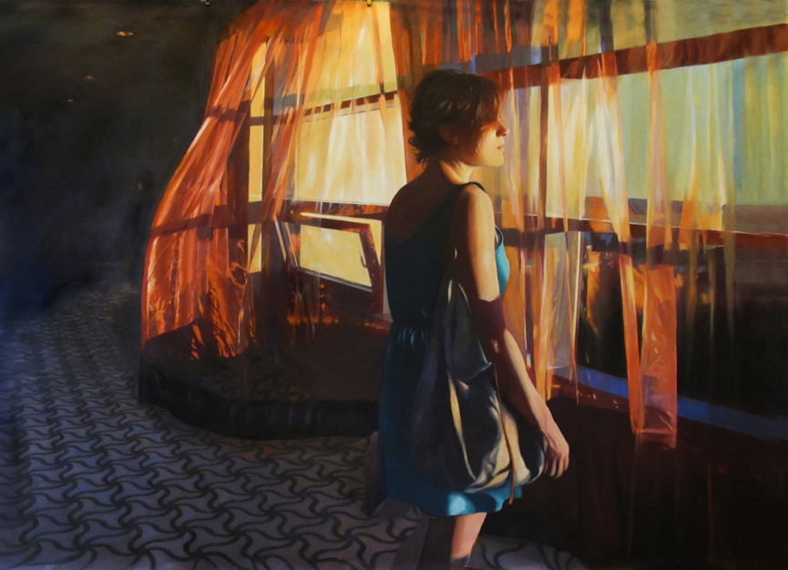

I can also relate to her art in the way she uses her own life and the world around her, just like artists like Sally Mann. I think her paintings are very cinematic in the way that they resemble frozen moments of a scene or an incident. I use the world around me more as a tool and a means to tell something that I am interested in. To combine the personal with the universal. I feel very inspired by her as an artist and we can discuss each other’s work. We also have the same taste when it comes to music and art, and I am very influenced by all the impressions I got from my childhood. The art exhibitions my parents took me to, that I didn’t appreciate then, but I do now. The music they played, Cohen, Dylan. I know so many songs by heart. The stories they told. What you experience as a child plays a really importance role in the rest of your life. I started writing short stories inspired by my mother’s paintings as a child.

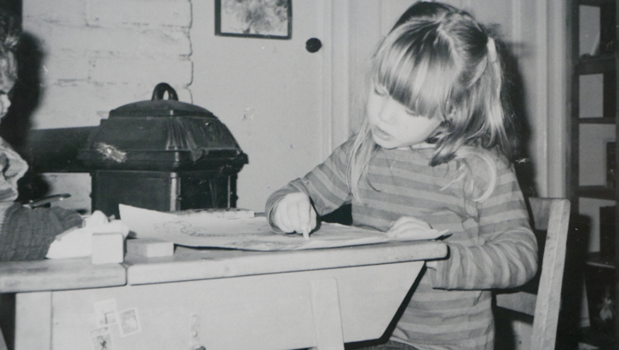

We both express ourselves through art, more than through words. Yet, I think it is important to give a language to your experiences, to make them real and not reduce yourself. It’s easy to avoid the things that are hard to talk about, but since I have lived so many years in denial, trying to pretend that everything was fine, holding up a shield, I am now more interested in breaking the walls and showing myself vulnerable. Looking into the scars and wounds, and not being afraid of revealing them.
There are many reasons why you keep things inside. I used to think that my own problems were never important, even at times when I didn’t see any meaning in anything. I was ashamed because I had everything and all the conditions to be happy, and still I was not –when there are so many people who really suffer and live under the most terrible conditions. In the film there is a scene where my mother is looking out to the landscape, and I say: ‘We live here in our paradise, while the world is in flames and crashes over us.’ There is a small world, your own private universe, and then there is the big world outside of your own, but they are always related.

Do you believe in love?
Love is probably the only thing I really believe in. Without love, without interaction with others, we are nobody. We reflect ourselves in the other, and when I see beauty in someone, hopefully that person will feel beautiful. There is a line in a song by Blonde Redhead: ‘If you start doubting me then I start to doubt myself’. We are so dependent on each other we come to live through each other. I think we affect each other very much, and small actions can have a profound influence. Just the way we see each other. The energy we spread around us. A smile from a stranger in the crowd. That is also love. Love exists in so many different forms. We all want to be loved for who we are. That is something we share. Probably that’s why love is a never-ending theme in so many films and songs.
In my film For You Naked two people fall in love without speaking each other’s language. They have to find other ways to get to know each other. I think it’s interesting because it’s easy to tell the same story about yourself. How do you present yourself to the other when you want to put yourself in a good light? Language can also be a protection where you just repeat the same story over and over again.

Freedom seems to play a key role in your life. When do you feel free?
My mother says in the film: ‘If freedom is not feeling ashamed of yourself, then I am far from being free.’ I really think that freedom and shame are related. If you feel ashamed of yourself, of your body, of who you are, then you are not really free.
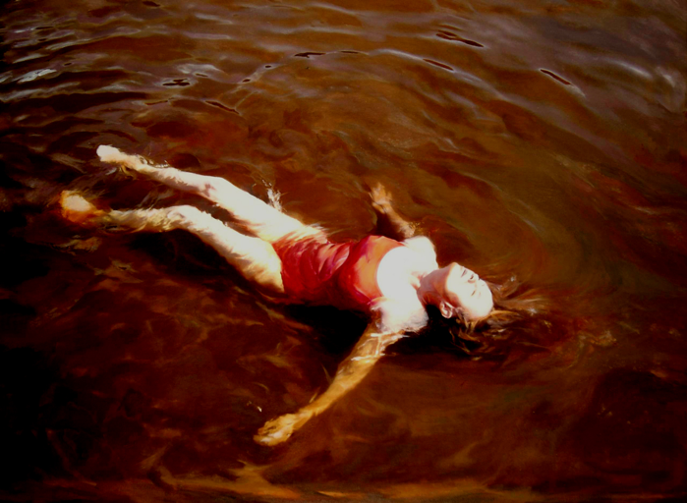

I feel free when I am surrounded by good energy in people and places. Places where there is air to breathe and things are not totally defined or formed. I am very sensitive to atmospheres and sounds. Freedom doesn’t mean leaving everything behind and taking off, but being in tune with yourself and the choices you make. At the same time, there is so much that we can never control, and in that sense we are not really free. I recently watched a great documentary, A Hard Loving Woman, at Tribeca Film Festival, which screened in the same programme as my short film Homeland. It is about Juliette Lewis and how she left Hollywood and started a rock band. She talks about beauty and how she never could adapt to the beauty ideal. When she goes on stage, she wants to be without makeup and just full of raw energy. It’s very empowering to see a woman who just doesn’t care at all, who doesn’t need to please others. I think that is the opposite of feeling shame. A little child doesn’t feel shame. There is a scene in the film where my sister’s daughter, Alma, aged four, sits in front of the mirror and puts on lipstick. She is playing; it’s a game. But it is also scary, how a four-year-old girl already knows women’s ‘codes’, the way she paints her nails, the way she moves. She knows exactly how to do it, imitating what she’s seen.

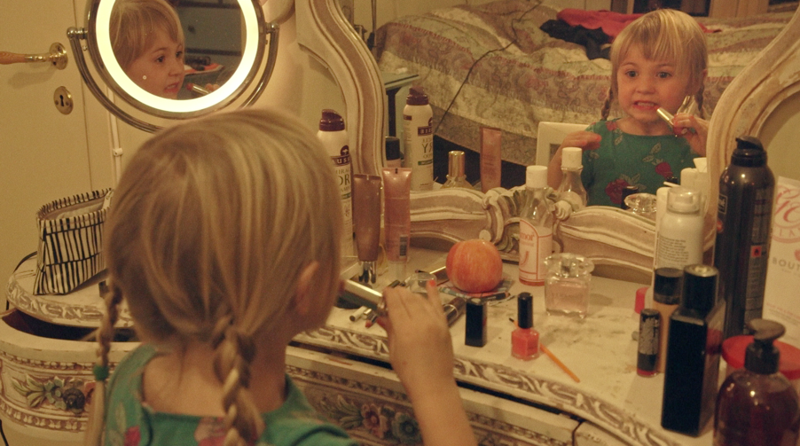

Who do you want to be?
I’m often surprised when I find out things about myself I didn’t know. I don’t think we have one true self but many different faces. Rilke writes about that in The Notebooks of Malte Laurids Brigge: how we consist of so many different layers and faces. We walk around with them and put them on – sometimes one face gets worn out, or becomes thin like paper.
I have spent so many years of my life trying to be someone else and looking for something else, with a restlessness that in some ways is positive, because it’s about being curious, longing to explore, to move on. But there is also another side to it, when you’re always on the run, feeling independent and free, without anything keeping you. Loneliness can be brutal sometimes. I don’t have the same restlessness anymore. My mother talks about that in the film, that she no longer yearns for somewhere else, not in the same way as before, when she always carried a diffuse longing for elsewhere.
I appreciate to be in one place for a longer time; at the same time, I have a nomadic mind so I can get up and leave any minute. And I still love that feeling of being on the road, on my way, playing good music, watching the landscape changing, being in transit. Or just waiting for the plane at the airport, or arriving to a new place where I’ve never been before and don’t know what to expect.

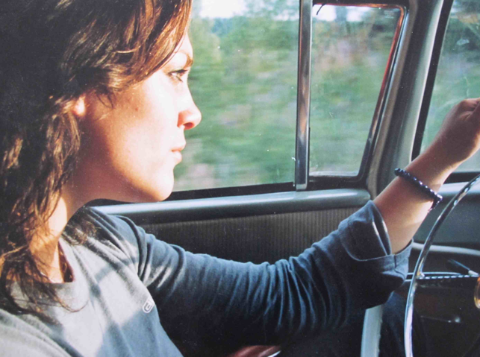

I now spend more time in the countryside in Sweden, where I have an old house. I also live part-time in Berlin. These two places are very good for me because I feel so much at home and alive. There is no pretence. It just is what it is, natural, beautiful and raw. There’s a title of a book by Robert Frank: ‘Hold Still – Keep Going’. I very much believe in that. To not rush, but to be present. I think that’s the most important thing for a filmmaker or an artist. I work in a very intuitive way. I always have my camera with me.

Failure: How do you feel about it?
When I grew up, I felt like my whole life was a failure compared to others. My parents were artists, our home was chaotic and unconventional. We lived in the countryside in Sweden, our neighbours were farmers. My friends’ parents had normal jobs. I was ashamed and wanted to be like everybody else. In the film, there is a passage with a little girl with a cute dress, Sophia. We were best friends. I adored her. She was so pretty, their home picture-perfect. I felt like a failure compared to her. But underneath the surface things weren’t that perfect. And she dreamt of my life.

Now when I look back I am happy that it was not all perfect and that I have the experience of what it means not to fit in. I had to find my own way. Feeling that I was not in the right place made me curious to explore other worlds. I started travelling at an early age and went alone on trains in Eastern Europe for the first time when I was 15. I was very shy and had an old Hi 8 camera that I used to film everything I saw, people I met – a way to communicate and get in touch with people. I was so full of questions about love, the feeling of home, and I ended up filming very personal conversations with people I met on trains and in places in Bosnia, Romania, Bulgaria, Italy, all around Europe. I am now using that archive material for my new film, Notes On A Journey. Feeling different or feeling like a failure can also be a driving force for you to search for others who share your experience. I felt much more at home in Bosnia than I did in my own small village in the countryside.
There was a period in my teens when I revolted against the chaos that was around me, growing up in an artist family and a messy home, and with parents who were different. Everything had to be perfect. I loved writing, but suddenly it was related to prestige. I wrote chronicles for a daily newspaper, a full-page article every Saturday. I won many prestigious literary prizes. I was the youngest ever to receive a journalist prize at the age of 18. I was offered a book contract. I did everything right. I was successful from the outside. Yet, inside I was torn apart and very unhappy. It was all just a shell. The more successful I became the more distant from myself. Finally, I didn’t know what I wanted anymore, and all the passion was gone. When you are afraid of failure, you stick to the well-known, which I believe is the greatest threat to creativity.
I don’t care so much anymore about being loved by everyone; I am interested in the notion of failure, what that means. Also, the complementary idea: success, what that means. Of course, I want to always do the best I can, and I want people to like what I do. But who decides what is a failure? To write one great script, maybe you have to write ten bad ones before you get there. When I showed the first versions of my film to my mentor, Stefan Jarl, it was ‘a failure’ and I knew it, but it was part of the process. I believe that we need to defuse the fear of failure.

What do you want people to think and feel as they are leaving the theatre?
After a screening at Gothenburg Film Festival, a woman came up to me and hugged me, saying, ‘Thank you for making this film! The first thing I will do when I go home is call my daughter. We never really talk.’

